AgroChain: Blockchain-Enabled GPS Rover for Precision Fertilizer Management and Farm Traceability

A PROJECT REPORT

submitted by

CB.EN.U4EEE23005 DEEPSHIGA M

CB.EN.U4EEE23015 KRISHNA PRIYANKA R

CB.EN.U4EEE23018 NAMITHA C JAYAN
CB.EN.U4EEE23041 THILAK V N

in partial fulfillment for the award of the degree

of

BACHELOR OF TECHNOLOGY

IN

ELECTRICAL AND ELECTRONICS ENGINEERING



AMRITA SCHOOL OF ENGINEERING, COIMBATORE

AMRITA VISHWA VIDYAPEETHAM
COIMBATORE- 641112
October 2026

AMRITA VISHWA VIDYAPEETHAM
AMRITA SCHOOL OF ENGINEERING, COIMBATORE, 641112



BONAFIDE CERTIFICATE

This is to certify that the project report entitled, Agrochain: Blockchain Enabled GPS-Rover for Precision Fertilizer Management and Farm Traceability
submitted by

DEEPSHIGA M CB.EN.U4EEE23005

KRISHNA PRIYANKA R CB.EN.U4EEE23015

NAMITHA C JAYAN CB.EN.U4EEE23018
THILAK V N CB.EN.U4EEE23041

in partial fulfillment of the requirements for the award of the degree of Bachelor of Technology in ELECTRICAL & ELECTRONICS ENGINEERING is a bonafide record of the work carried out under my guidance and supervision at Amrita School of Engineering, Coimbatore.

Dr .Lekshmi R R
SUPERVISOR
Assistant Professor
Electrical and Electronics Engineering

Dr. Balamurugan S
CHAIRPERSON
Electrical and Electronics Engineering

This project report was evaluated by us on 30-07-2026

Dr. Anand R
INTERNAL EXAMINER
Assistant Professor
Electrical and Electronics Engineering

Mr Nakkeeran M
EXTERNAL EXAMINER
Assistant Professor
Electrical and Electronics Engineering

ACKNOWLEDGEMENT

We would like to express our sincere gratitude to our project guide, Dr. R. R. Lekshmi, for her invaluable guidance, constant support, and insightful suggestions throughout the course of this project. Her encouragement and constructive feedback have been instrumental in shaping the direction of our work.
We extend our heartfelt thanks to the Chairperson and faculty of the Department of Electrical and Electronics Engineering for providing us with the necessary facilities and a conducive environment to carry out this project.
We are also grateful to Amrita School of Engineering, Coimbatore, and Amrita Vishwa Vidyapeetham for granting us the opportunity and resources to pursue this project as part of our academic curriculum.
We would like to thank our team members for their collaborative effort, dedication, and teamwork throughout the various stages of this project.
Finally, we thank our families and friends for their constant support and encouragement throughout this endeavor.

ABSTRACT

In traditional agricultural system the productivity is decreased due to the excessive or inaccurate use of fertilizer, which degrades soil health and also increases cultivation cost. Whereas in precision agriculture, this can be overcome by minimizing the use of fertilizer. This project, Agrochain proposes a Blockchain Enabled GPS-Rover System for precision fertilizer management and farm traceability. This system is designed to collect environmental parameters such as pH, NPK, soil moisture level, and humidity from the field autonomously using the onboard sensors. For this data a Random Forest machine learning model recommends the suitable fertilizer based on the trained dataset. All cultivation and fertilizer application data are intended to be stored on a Blockchain to ensure tamper-proof, traceable and transparent record keeping between the producers and the consumers. These data can be accessed with the help of distinct QR code for distinct type of crops. In the first phase of development, the rover chassis have been assembled and made to move using 6 wheel drive configuration with DC geared motors and three L298N motor drivers, and a Neo-6M GPS module has been integrated for location tracking, and navigation logic combining GPS-based waypoint tracking with magnetic wheel encoder feedback is currently under development for precise field navigation.. This report presents the design methodology, literature survey, current hardware implementation along with the workplan for the subsequent phases such as involving soil sensor integration, machine learning model development, and blockchain deployment.
Keywords— Precision Agriculture, GPS Rover, Blockchain, Random Forest, Fertilizer Recommendation, Soil Health Monitoring, Farm Traceability, IoT.

TABLE OF CONTENTS
CHAPTER |  | TITLE | PAGE No
 |  | LIST OF FIGURES | viii
 |  | LIST OF TABLES | viii
 |  | LIST OF SYMBOLS | ix
 |  | LIST OF ABBREVIATION | x
1 |  | INTRODUCTION | 1
 |  | 1.1 PREFACE | 1
 |  | 1.2 OBJECTIVE | 1
 |  | 1.3 MOTIVATION | 2
 |  | 1.4 PROBLEM STATEMENT | 2
 |  | 1.5 ORGANISATION OF THE REPORT | 2
2 |  | LITERATURE REVIEW | 3
 |  | 2.1 INTRODUCTION | 3
 |  | 2.2 LITERATURE SURVEY | 3
 |  | 2.3 LITERATURE REVIEW SUMMARY | 4
 |  | 2.4 RESEARCH GAP | 4
3 |  | SYSTEM DESIGN | 5
 |  | 3.1 BLOCK DIAGRAM | 5
 |  | 3.2 BLOCKCHAIN ARCHITECTURE | 5
 |  | 3.3 MACHINE LEARNING WORKFLOW  3.4 ROVER NAVIGATION WORKFLOW  3.5 SUBSYSTEM DESCRIPTION | 5
4 | PHASE 1 IMPLEMENTATION |  | 11
 | 4.1 HARDWARE ASSEMBLED |  | 11
 | 4.2 CIRCUIT AND CONFIGURATION |  | 11
 | 4.3 FIRMWARE AND MOTOR CONTROL LOGIC |  | 12
 | 4.4 RESULT AND OBSERVATIONS |  | 12
5 | WORKPLAN FOR SUBSEQUENT PHASES |  | 14
 | 5.1 REMAINING TASKS AND TIMELINE |  | 14
 | REFERENCES |  | 15

LIST OF FIGURES
Fig.No | FIGURE CAPTION | PAGE No.
3.1 | Block diagram of agrochain system | 06
3.2 | Architecture diagram of blockchain module | 07
3.3 | Flowchart of machine learning-based fertilizer recommendation | 08
3.4 | Flowchart of rover navigation logic | 09
4.1 | Voltage regulator circuit (16v to 5v step-down) | 12
4.2 | Photograph of assembled rover chassis | 13
4.3 | Set up of esp32 cam | 13
4.4 | Out put of esp 32 cam | 14

LIST OF TABLES

Table.No | TABLE TITLE | PAGE No.
5.1 | Project work plan and timeline | 08

LIST OF SYMBOLS

S.No | SYMBOL | DEFINITION
1 | D | Duty cycle
2 | Vin | Input voltage
3 | Vout | Output voltage
LIST OF ABBREVIATIONS

S.NO | ABBREVATION | EXPANSION
1. | GPS | Global Positioning System
2. | ML | Machine Learning
3. | NPK | Nitrogen Phosphorus Potassium
4. | IOT | Internet Of Things
5. | QR | Quick Response
6. | ME | Magnetic Encoder
7. | DC | Direct Current

Chapter 1
INTRODUCTION

1.1 PREFACE
Agriculture continues to be one of the most vital and primary sector for a Country’s economy and food security, yet it still faces problems due to factors such as inefficient usage of resource. Among these, primary concern is for excessive or inaccurate application of fertilizers that causes not only increase in cultivation cost but also degrades the soil fertility over time that leads to the reduction in long time productivity. Precision agriculture came up with a solution for this problem using modern technologies such as sensors, automation, and data driven decision making which optimize the usage of resources based on the actual field conditions rather than general assumptions.
The project, AgroChain, proposes the Blockchain Enhanced GPS Rover System for precise fertilizer application and agricultural traceability. The system is intended to send out an autonomous GPS guided rover to collect soil and geographical data of the field, run a machine learning algorithm to recommend appropriate fertilizers according to the collected soil nutrient parameters and store all the records of cultivation and fertilizer application securely on a blockchain to ensure transparency and traceability in the agricultural process.

1.2 OBJECTIVES
The primary objectives of this project are:
- To develop a blockchain-enabled GPS rover for precision fertilizer management and farm traceability
- To collect GPS location data and soil nutrient parameters using an autonomous rover
- To predict the most suitable fertilizer for given soil conditions using a machine learning model
- To securely store farm records using blockchain technology
- To provide a transparent and tamper-proof record of cultivation history accessible to both farmers and consumers

1.3 MOTIVATION
A common problem in conventional farming is over-application of fertilizer, which can be traced back to the lack of accurate, field-specific recommendations. This not only raises the cost of inputs for the farmers, but also causes a long-term decline in the soil fertility. But farm records kept by hand can be lost, changed or disputed, providing little in the way of verifiable evidence of how a crop was grown. Here is where blockchain technology comes in, offering a secure and tamper-proof way to store agricultural records. Machine learning, in turn, enables accurate, data-driven fertilizer recommendations based on actual soil conditions. These technologies enable a smart, transparent and trustworthy precision farming system.

1.4 PROBLEM STATEMENT
This project addresses the following key questions:
- Can an autonomous GPS-based rover accurately collect soil and environmental parameters such as pH, NPK values, soil moisture, temperature, humidity, and location data for precision agriculture applications?
- Can a machine learning model accurately recommend the most suitable fertilizer based on soil nutrient conditions and field data?
- Can the rover autonomously perform precise fertilizer application according to machine-learning-generated recommendations?
- Can blockchain technology provide secure, immutable, and tamper-proof storage of cultivation records, fertilizer applications, and harvest information?
- Can the integration of autonomous robotics, machine learning, blockchain, and QR-based traceability improve transparency, automation, and decision-making in smart agriculture compared to conventional farming practices?

  - ORGANISATION OF THE REPORT
The structure of this report is: Chapter 2 provides the review of the existing literature related to precision agriculture, fertilizer recommendation systems, blockchain based traceability, agricultural robotics and the identified research gap. Chapter 3 describes the overall system design, including the block diagram and the blockchain architecture. The hardware implementation carried out in the first phase is described in Chapter 4. Chapter 5 describes the work plan for the next phases of the project.
Chapter 2
LITERATURE REVIEW
2.1 INTRODUCTION
Literature review is done to understand the different types of approaches in precision agriculture, particularly focusing on fertilizer recommendations systems, agricultural robotics, IoT-based monitoring, and blockchain integrated in farming. A total of 48 papers are reviewed, which was published between 2022 and 2026 which covers four main areas: Fertilizer recommendation, machine learning, blockchain, and robotics/IoT.

2.2 LITERATURE SURVEY
A wide body of recent work addresses precision agriculture from several angles. Zaaboub et al. [1] built a blockchain and IoT-based framework aimed at making smart agriculture more transparent and traceable, an idea echoed in [2], where interpretable machine learning is used to identify plant diseases and nutrient deficiencies from field images. Similarly, [3] and [4] apply IoT sensing together with machine learning for crop disease detection and yield optimization, showing how sensor data and predictive models are increasingly paired in agricultural monitoring systems.
Blockchain's role in agricultural supply chains has drawn considerable attention as well. [5] and [6] each conducted systematic reviews — the former looking broadly at blockchain in agricultural supply chains, the latter narrowing in on the specific challenges Indian farmers face when adopting the technology. Meanwhile, robotics started appearing in the literature around the same period, with [7] developing an autonomous mobile robot capable of spraying fertilizer without manual intervention.
Fertilizer and crop recommendation using machine learning forms one of the largest clusters within this literature. Papers [8] through [15] approach the problem from slightly different angles — some using standard classifiers, others favoring Random Forest specifically, and a few (like [10]) combining multiple algorithms in a hybrid setup to squeeze out better accuracy. What's consistent across all of them is the reliance on soil nutrient parameters (N, P, K, pH, and similar readings) as the core input features driving these predictions.
A second, related thread looks at combining IoT with machine learning for on-field diagnostics — [16] pairs crop recommendation with leaf disease diagnosis, while [17] leans on CNN-based deep learning specifically for identifying rice leaf disease. On the traceability side, [18] and [19] each propose blockchain-based systems for tracking food and crops through the supply chain, and [20] takes a slightly different angle by focusing on device-level authentication for IoT systems used in smart farming. [21] returns to the robotics theme, describing a farming robot built for precision seed sowing and targeted irrigation, controlled wirelessly.
Several more recent papers refine earlier recommendation approaches. [22] and [23] both work on improving fertilizer/crop suggestions and nutrient deficiency detection respectively, the latter using a MobileNet-based model. [24] looks at securing agricultural data through blockchain, and [25], [26] each propose decentralized frameworks — one focused on access management, the other on scalability and how easily farmers can actually adopt such systems in practice. [27] and [28] step back to take a broader review-style look at machine learning and IoT trends across agriculture, and [29] applies machine learning specifically to leaf-based plant health assessment.
Marketplace and trading applications of blockchain show up in [30] and [31], both aimed at connecting farmers directly with buyers or improving the fairness of agricultural trade. Vedula and Arunachalam appear repeatedly across this literature [32], [42], [44], consistently exploring blockchain-Ethereum integration with IoT for pest detection and irrigation control — a theme that seems to be a sustained research direction for that group. [33] introduces Merkle tree verification as an access-control mechanism within blockchain-based smart farming, while [34] goes further, proposing a federated, GRU-based digital twin architecture — a considerably more complex system aimed at agricultural recommendation. [35] and [36] round out this stretch, looking at smart contracts for trust-building and survival-analysis-based crop recommendation respectively.
The remaining papers cover a fairly broad spread of related ideas: [37] reviews data-driven ML techniques generally; [38] and [39] each propose blockchain-IoT frameworks for secure data sharing and scalability; [40] designs a three-tier blockchain architecture with GPS-verified delivery, tying logistics into the traceability picture; [41] takes a bibliometric look at how ML research in African agriculture has evolved; and [43] proposes an explainable AI framework geared toward sustainable resource use. Finally, [45] applies ML to both disease prediction and fertilizer optimization together, [46] integrates blockchain with IoT for better data integrity, [47] proposes a digital twin model connecting crop nutrition to public health outcomes, and [48] closes out the set with a decentralized architecture for real-time task validation in smart agriculture systems.
Taken together, this literature shows strong, mature work happening independently in machine learning-based recommendation, blockchain-based traceability, and robotics/IoT-based automation — but as the next section discusses, these three threads are almost never brought together into one working system.
One of the most closely related works, "Blockchain-Based Crop Recommendation System for Precision Farming in IoT Environment" [49], uses fixed IoT sensors for data collection and blockchain for storing sensor and crop data. However, this approach relies on static sensor infrastructure rather than autonomous field data collection, does not incorporate GPS-based field mapping, and provides only crop recommendation output rather than fertilizer-specific recommendations — gaps that this project's AgroChain system directly addresses.

2.3 SUMMARY
The reviewed literature indicates that existing research is largely concentrated in three distinct areas. A substantial portion of studies apply machine learning, particularly Random Forest and related classifiers, to improve the accuracy of fertilizer and crop recommendation based on soil nutrient data. A parallel body of work examines blockchain technology as a means of ensuring transparency, traceability, and secure storage of agricultural records, particularly within supply chain and food safety contexts. A comparatively smaller set of studies incorporates robotics or IoT-based field data collection, typically paired with either machine learning or blockchain individually, but rarely with both. Across the literature, these three technological directions — machine learning, blockchain, and robotics/IoT — are almost always implemented and evaluated as separate systems rather than as an integrated, end-to-end platform. This pattern indicates a clear opportunity for a combined system that brings autonomous field data collection, intelligent fertilizer recommendation, and secure blockchain-based record-keeping together within a single precision agriculture solution.

2.4 RESEARCH GAP
Most of the existing studies are on fertilizer recommendation, blockchain-based traceability, or autonomous robotics as separate research domains. Very few studies attempt to combine a GPS guided rover, real-time soil nutrient analysis, a machine-learning based fertilizer recommendation and a blockchain based farm record keeping into one system. This clearly points to the need for an integrated precision agriculture platform that combines autonomous data collection, intelligent decision making and secure traceability – which constitutes the basis for the AgroChain system proposed in this project.

Chapter 3
SYSTEM DESIGN
3.1 BLOCK DIAGRAM
The block diagram illustrates the overall architecture of the AgroChain system and the flow of data between its major subsystems. At the core of the system is the rover mobility unit, which navigates the field using GPS-based waypoint tracking supported by magnetic wheel encoders for precise short-distance movement. Mounted on the rover, the sensor acquisition unit — comprising the pH sensor, NPK sensor, soil moisture sensor, and DHT11 temperature/humidity sensor — continuously collects environmental parameters as the rover moves through the field. This sensor data is transmitted to the machine learning unit, where a trained Random Forest classifier processes the input parameters and generates a fertilizer recommendation. The recommendation, along with the corresponding field location and timestamp, is passed to the blockchain unit, which records the cultivation and fertilizer application event as an immutable transaction. This data becomes accessible to farmers and consumers through the QR-based traceability interface, which allows verification of a crop's cultivation history by scanning a linked QR code. The block diagram thus represents the complete data pipeline from field sensing to consumer-facing traceability.
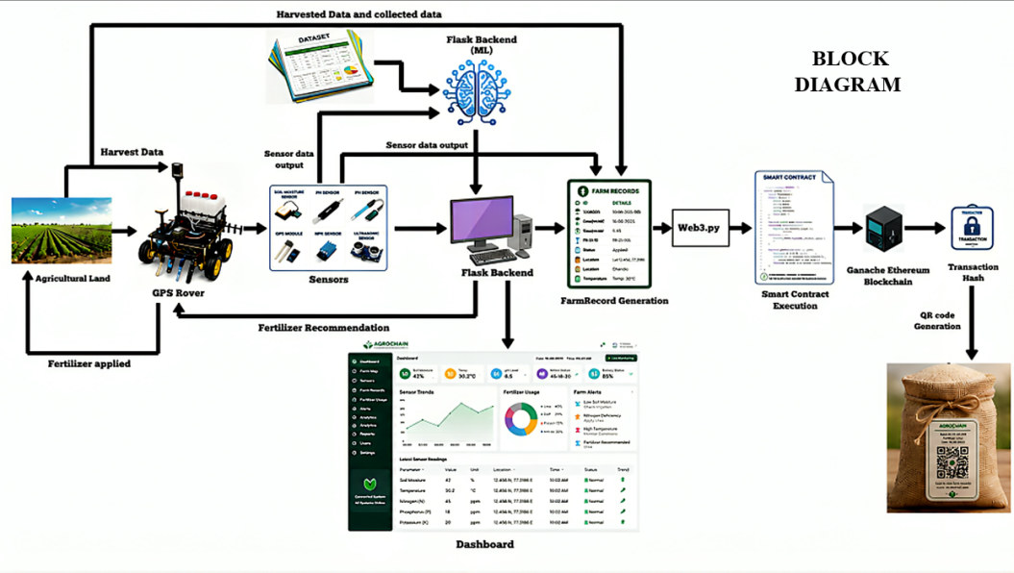
Figure 3.1 Block Diagram of AgroChain System

3.2 BLOCKCHAIN ARCHITECTURE
The blockchain architecture diagram illustrates how cultivation and fertilizer data is structured, validated, and stored within the system. Sensor readings and machine-learning-generated fertilizer recommendations are packaged into a transaction, which is submitted to a smart contract deployed on the blockchain network. The smart contract, developed using Solidity, validates the transaction and executes predefined logic, recording the fertilizer type applied, the field location, and the timestamp of the event. Once validated, the transaction is added as a new block, cryptographically linked to the previous block in the chain, ensuring that historical records cannot be altered or deleted without detection. This distributed ledger structure is tested locally using Ganache during development, with Web3.py used to interface between the backend application and the deployed smart contracts. Each finalized block is linked to a unique QR code corresponding to a specific crop batch, allowing any stakeholder to retrieve and verify the complete, tamper-proof cultivation history of that crop.
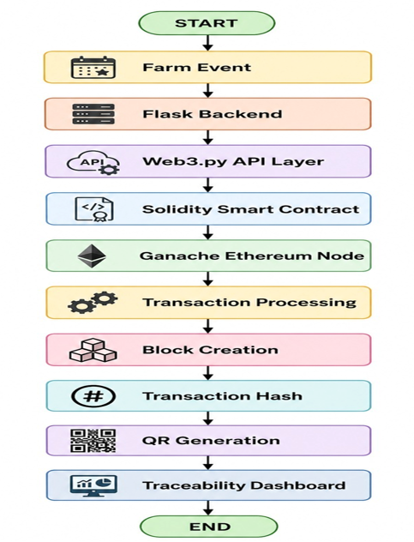
Figure 3.2 Architecture Diagram of Blockchain Module

3.3 MACHINE LEARNING WORKFLOW
The machine learning flowchart describes the process by which the system generates fertilizer recommendations from collected field data. The process begins with data acquisition, where soil and environmental parameters — nitrogen (N), phosphorus (P), potassium (K), pH, soil moisture, temperature, humidity, and crop type — are collected via the rover's onboard sensors. This raw data undergoes preprocessing, including handling of missing values and encoding of categorical variables such as soil type and crop type, to prepare it for the model. The preprocessed data is passed into the trained Random Forest classifier, which was trained offline on the Fertilizer Prediction dataset covering 11 crop types and 7 fertilizer classes. The model evaluates the input feature set and outputs a predicted fertilizer class best suited to the current soil and crop conditions. This output is forwarded to the blockchain module for permanent record-keeping and, where applicable, used to trigger the rover's automated fertilizer dispensing mechanism.
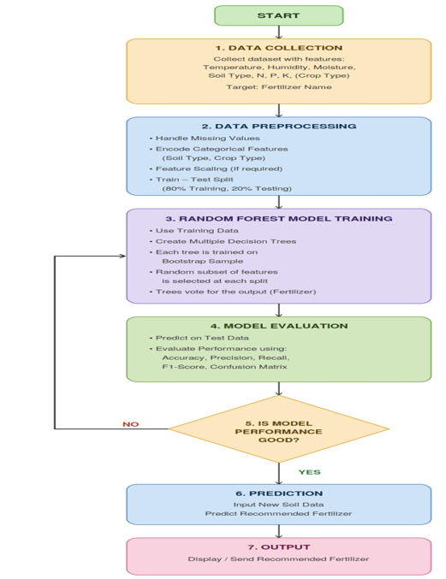
Figure 3.3 Flowchart of Machine Learning-Based Fertilizer Recommendation

3.4 ROVER NAVIGATION WORKFLOW
The rover navigation flowchart illustrates the decision-making logic governing the rover's movement through the field. The process begins with the rover reading its current position from the Neo-6M GPS module and comparing it against the next target waypoint in its predefined field path. If the rover is not within an acceptable distance of the waypoint, it calculates the required heading and initiates movement, with magnetic wheel encoders continuously tracking wheel rotation to measure the exact distance traveled and enable precise stopping and turning. Throughout movement, the ultrasonic sensor monitors for obstacles in the rover's path; if an obstacle is detected within a threshold distance, the rover halts and executes an avoidance maneuver before resuming its course toward the waypoint. Once the rover reaches the target waypoint, it either performs sensor data collection and fertilizer dispensing at that point or proceeds to the next waypoint, repeating this cycle until the entire predefined field path has been covered.
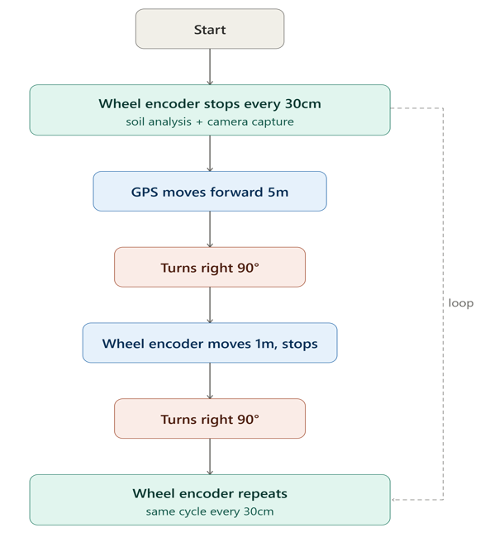
Figure 3.4 Flowchart of Rover Navigation Logic

3.5 SUBSYSTEM DESCRIPTION
- Rover Mobility Unit: A 6-wheel drive chassis powered by DC geared motors and controlled via three L298N motor drivers, providing the physical platform for autonomous field movement.
- GPS and Navigation Unit: A Neo-6M GPS module for long-range location tracking and field navigation, combined with magnetic wheel encoders for precise short-distance movement and positioning, along with planned integration of pH, soil moisture, NPK, and DHT11 (temperature/humidity) sensors for environmental data collection.
- Machine Learning Unit (planned): A Random Forest classifier trained on a fertilizer prediction dataset covering 11 crop types and 7 fertilizer classes, to recommend suitable fertilizers based on collected soil parameters.
- Blockchain Unit (planned): A blockchain framework (developed using Solidity smart contracts and Web3.py integration) to securely store cultivation and fertilizer application records.
- Traceability Interface (planned): A QR-code-based system allowing farmers and consumers to access the verified cultivation history of a specific crop.
Chapter 4
PHASE 1 IMPLEMENTATION
4.1 HARDWARE ASSEMBLED
In the first development phase, the physical mobility platform of the AgroChain rover was assembled and made functional. The rover uses a 6-wheel drive chassis powered by DC geared motors, controlled through three L298N motor driver modules to independently manage the motor pairs across the chassis. Power is supplied through a 16V rechargeable battery, with a voltage regulator circuit used to step down the supply to 5V for powering the ESP32-CAM and GPS module logic circuitry. An ESP32-CAM module serves as the main controller, selected for its processing capability and integrated Wi-Fi and camera support, the latter intended for image-based field monitoring in later phases. A Neo-6M GPS module has been integrated with the ESP32-CAM to enable location tracking, supporting the waypoint-based navigation planned for implementation in the next phase.

4.2 CIRCUIT AND WIRING CONFIGURATION
The ESP32-CAM's GPIO pins are connected to the three L298N motor drivers to control the direction and speed of the DC geared motors on each side of the chassis. Since the DC geared motors and L298N drivers operate directly from the 16V battery supply, a separate voltage regulation stage is required to safely power the ESP32-CAM and GPS module, which operate at 5V logic level. A buck converter module is used for this purpose, stepping down the 16V input to a stable, regulated 5V output. A buck converter was selected over a linear regulator such as the LM7805, as it offers significantly higher efficiency and generates minimal heat despite the large voltage drop involved. The duty cycle required for the buck converter to step down the 16V input to the regulated 5V output is given by:
D = Vout / Vin = 5 / 16 ≈ 0.31 (1)
where D is the duty cycle, Vout is the regulated output voltage, and Vin is the input battery voltage.
Input and output filtering capacitors are included to stabilize the regulated supply. This dedicated 5V line powers the ESP32-CAM and Neo-6M GPS module independently of the motor power line, preventing voltage fluctuations caused by motor current draw from affecting controller stability.
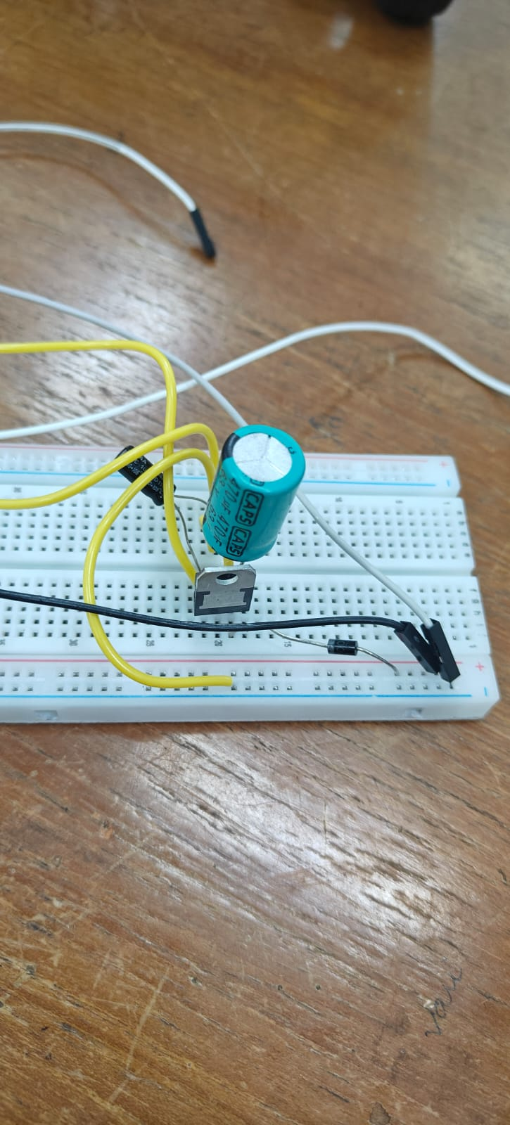
Figure 4.1Voltage Regulator Circuit (16V to 5V Step-Down)

4.3 FIRMWARE AND MOTOR CONTROL LOGIC
The rover's firmware, implemented on the ESP32-CAM, controls motor direction and speed through digital output signals sent to the three L298N motor driver modules. Each motor driver receives independent direction control signals, allowing the rover to execute forward movement, reverse movement, and left or right turns by varying the relative direction and speed of the motors on each side of the chassis. Motor speed is regulated using pulse-width modulation (PWM) signals generated by the ESP32-CAM, allowing finer control over rover velocity during navigation. The firmware integrates motor control with position feedback from the magnetic wheel encoders, enabling the system to execute precise, distance-based movement commands rather than relying solely on time-based motor activation. Basic movement functions — forward, reverse, and turning — have been implemented and verified in this phase.
4.4 RESULTS AND OBSERVATIONS
Initial testing confirmed that the rover chassis moves reliably on flat ground using the DC motors and L298N drivers. Work is currently underway to implement and test navigation logic that combines GPS-based waypoint tracking with feedback from the magnetic wheel encoders, in order to achieve accurate short-distance positioning and turning during field operation.
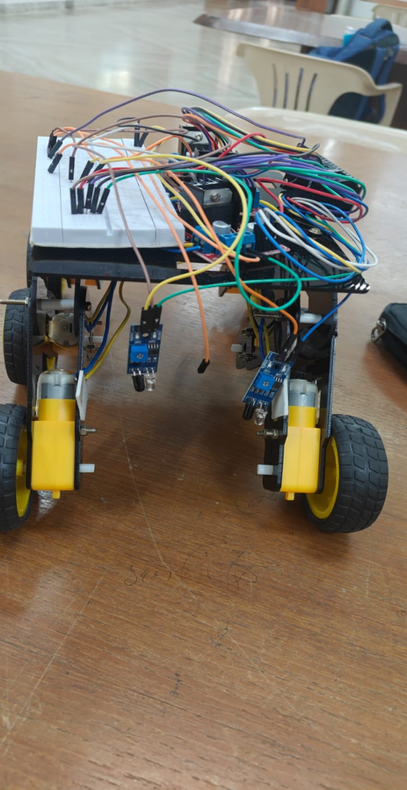
Figure 4.2 Photograph of Assembled Rover Chassis
The ESP32-CAM implementation was successfully completed, and the deployed object detection model was able to detect a pen in real time with high confidence. The successful detection verifies the proper integration of the hardware and AI model, demonstrating reliable real-time object recognition on the ESP32-CAM.
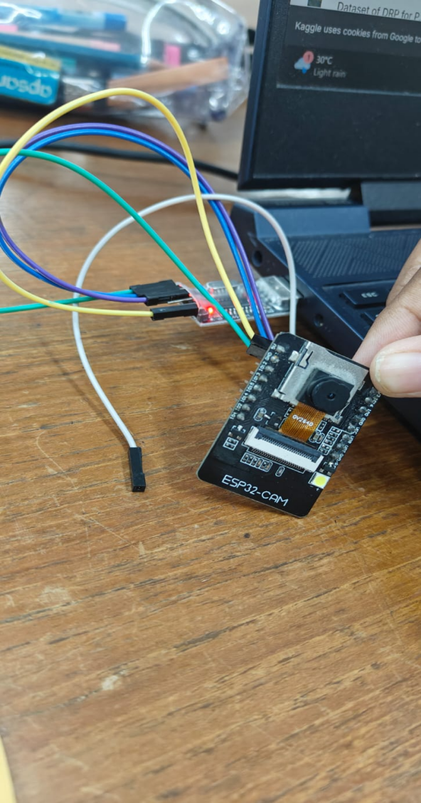
Figure 4.3 Set up of ESP32 Cam

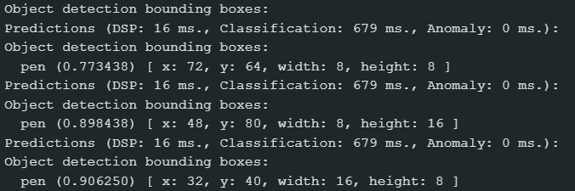

Figure 4.4 Output of ESP32 Cam

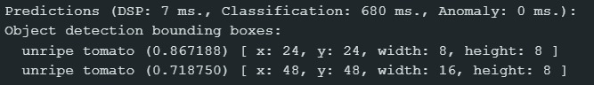
Figure 4.5 Output when ESP32 Cam senses unripe tomatoes

According to the inference result of Edge Impulse, the ESP32-CAM device is able to detect the unripe tomato from the field of view. As shown in Figure 4.5, there were two bounding boxes that were created with confidence levels of 0.867 and 0.719 respectively while the object was classified into "unripe tomato." The whole process of inference took 7ms for DSP processing and 680ms for classification, without any anomaly being detected.

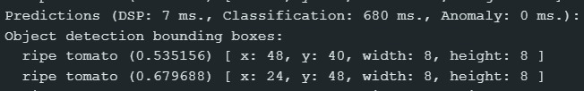
Figure 4.6 Output when ESP32 Cam senses ripe tomatoes

Equally, the model was tested on a ripe tomato, and as seen in Figure 4.6, resulting in two bounding boxes marked "ripe tomato," with confidence levels of 0.535 and 0.680, respectively. From this, it has been shown that the model is able to distinguish between the unripe and ripe conditions of the same fruit, which is an important aspect in achieving the final objective of crop health automation monitoring while traversing using the rover. The processing times were similar to the previous test, taking 7 ms for DSP and 680 ms for classification.

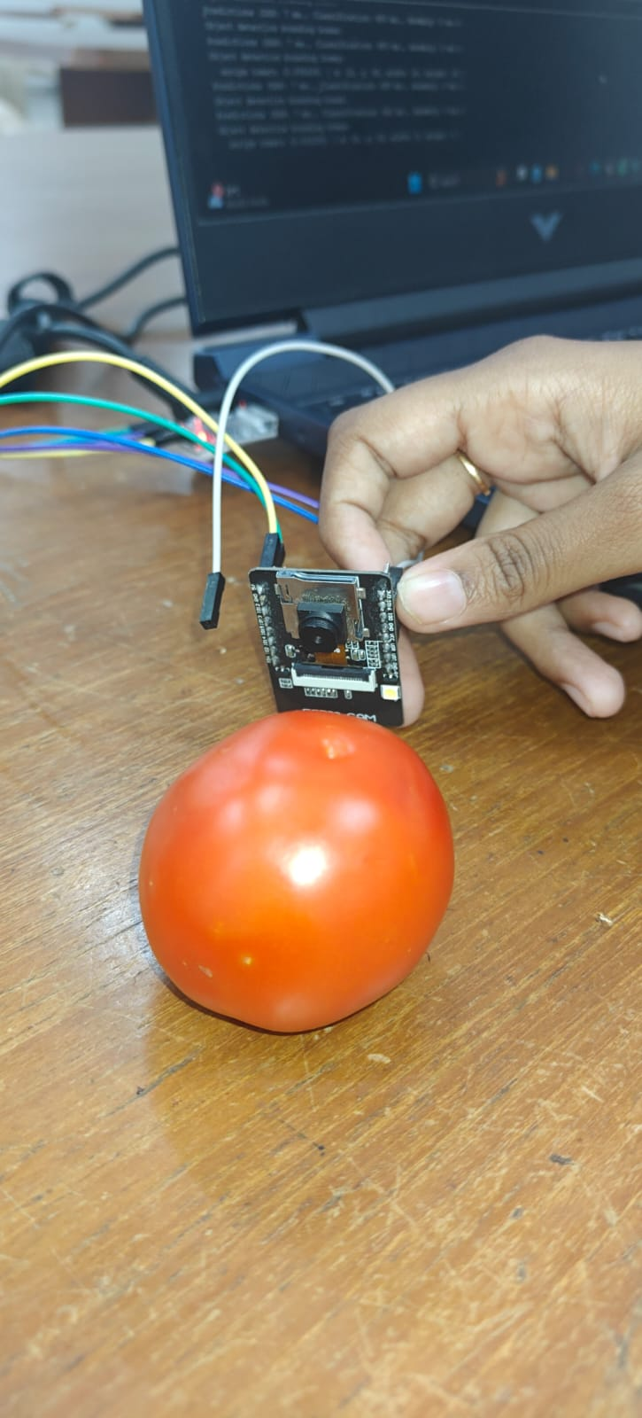
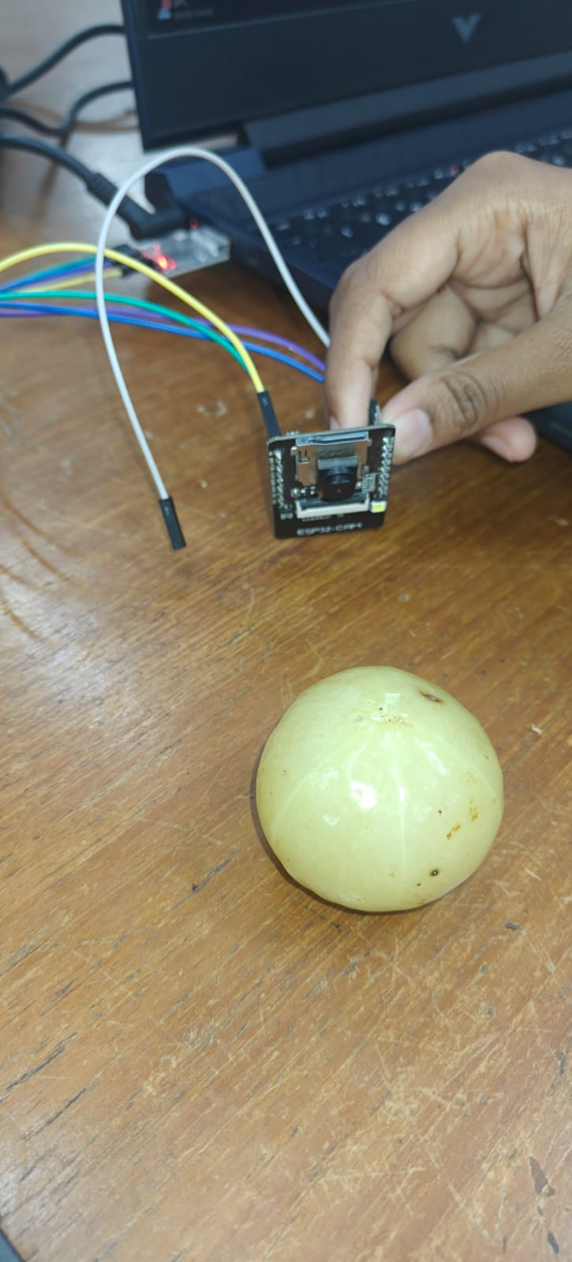

Figure 4.7 Physical test setup used to validate the object detection model

Overall, the Phase 1 results confirm that both the mechanical and intelligence subsystems of the AgroChain rover are functioning as intended. As can be seen from Figure 4.2, the chassis reliably achieves basic locomotion using the DC motor and L298N driver setup, while the ESP32-CAM successfully runs a real-time object detection model capable of distinguishing between ripe and unripe tomatoes with high confidence and low latency. These outcomes validate the core hardware-software integration achieved in this phase and establish a solid foundation for the subsequent phases, which will focus on GPS-encoder-based precise navigation, expanded sensor integration, and eventual fertilizer recommendation and blockchain-based traceability.
Chapter 5
WORKPLAN FOR SUBSEQUENT PHASES

5.1 REMAINING TASKS AND TIMELINE

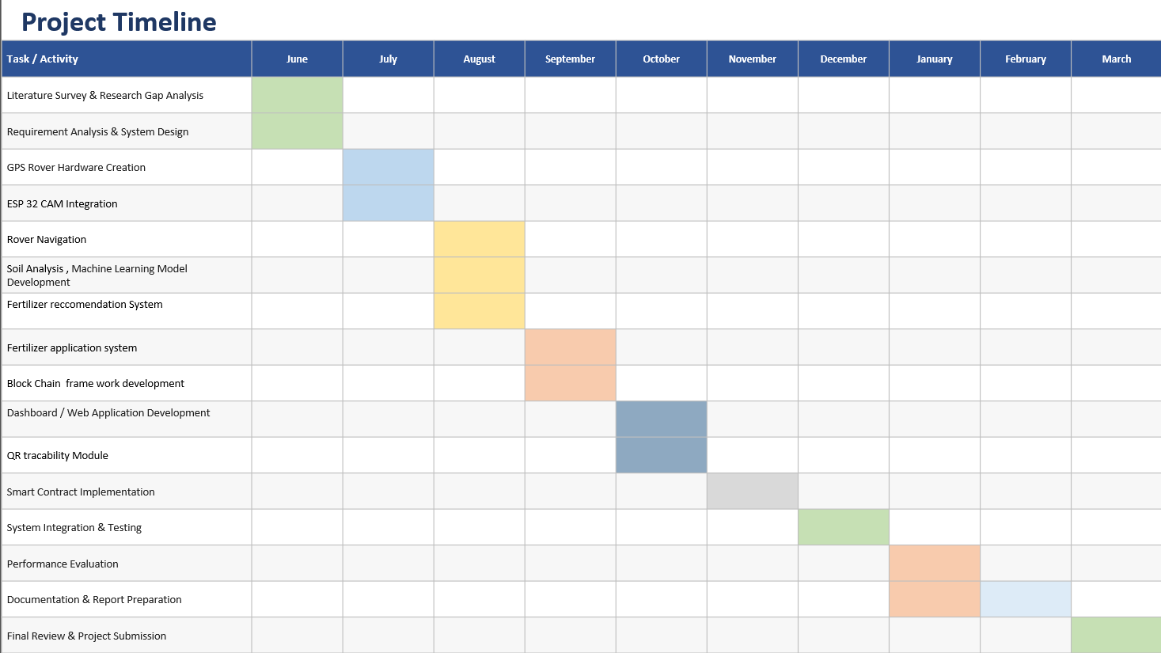
Table5.1: Project Timeline

REFERENCES

[1] L. Zaaboub, S. Belaib, S. Cherbal, A. Mashaleh and A. Gawanmeh, “A Blockchain and IoT-Based Framework for Transparent and Traceable Smart Agriculture: AlgroTech,” 2nd International Conference on Computational Intelligence Approaches and Applications (ICCIAA), Amman, Jordan, pp. 1–7, doi: 10.1109/ICCIAA68481.2026.11543923, 2026.
[2] J. Mkhatshwa and O. Daramola, “Image-Based Identification of Plant Diseases and Nutrient Deficiency Using Interpretable Machine Learning,” Third International Conference on Digital Data Processing (DDP), Luton, United Kingdom, pp. 98–101, doi: 10.1109/DDP60485.2023.00028, 2023.
[3] G. Manoharan, S. D. N. H. Ali, M. Sathe, A. Karthik, A. Nagpal and A. Sidana, “IoT-Based Crop Disease Detection and Management System Using Machine Learning Algorithms,” International Conference on Science Technology Engineering and Management (ICSTEM), Coimbatore, India, pp. 1–5, doi: 10.1109/ICSTEM61137.2024.10561056, 2024.
[4] G. Lakshmi, S. Brindha, V. Sathish, V. Manoj Kumar and P. Santhoshkumar, “Advancing Precision Agriculture: AI, IoT, and Machine Learning Solutions for Optimal Crop Yield,” International Conference on Communication, Computing and Internet of Things (IC3IoT), Chennai, India, pp. 1–5, doi: 10.1109/IC3IoT60841.2024.10550338, 2024.
[5] D. M. Vistro, A. Ur Rehman, M. S. Farooq and F. Khalid, “Role of Blockchain Technology in Agriculture Supply Chain: A Systematic Literature Review,” IEEE 2nd Mysore Sub Section International Conference (MysuruCon), Mysuru, India, pp. 1–8, doi: 10.1109/MysuruCon55714.2022.9972719, 2022.
[6] U. Sugandh, S. Nigam and M. Khari, “Blockchain Technology in Agriculture for Indian Farmers: A Systematic Literature Review, Challenges, and Solutions,” IEEE Systems, Man, and Cybernetics Magazine, vol. 8, no. 4, pp. 36–43, doi: 10.1109/MSMC.2022.3197914, Oct. 2022.
[7] A. R and R. K. Megalingam, “Autonomous Fertilizer Spraying Mobile Robot,” IEEE 19th India Council International Conference (INDICON), Kochi, India, pp. 1–6, doi: 10.1109/INDICON56171.2022.10039828, 2022.
[8] S. Iniyan, M. S. Raja, R. Srinivasan, C. Santhanakrishnan and A. Srinivasan, “Crop and Fertilizer Recommendation System Applying Machine Learning Classifiers,” International Conference on Emerging Research in Computational Science (ICERCS), Coimbatore, India, pp. 1–6, doi: 10.1109/ICERCS57948.2023.10433972, 2023.
[9] S. R. Sani, S. V. Sekhar Ummadi, S. Thota, N. Muthineni, V. S. Srinivas Swargam and T. S. Ravella, “Crop Recommendation System using Random Forest Algorithm in Machine Learning,” 2nd International Conference on Applied Artificial Intelligence and Computing (ICAAIC), Salem, India, pp. 501–505, doi: 10.1109/ICAAIC56838.2023.10141384, 2023.
[10] K. P. K. Devan, B. Swetha, P. Uma Sruthi and S. Varshini, “Crop Yield Prediction and Fertilizer Recommendation System Using Hybrid Machine Learning Algorithms,” IEEE 12th International Conference on Communication Systems and Network Technologies (CSNT), Bhopal, India, pp. 171–175, doi: 10.1109/CSNT57126.2023.10134662, 2023.
[11] B. S. Shedthi, V. Shetty, Anusha, R. R. Shetty, A. Shetty and B. A. D. Alva, “Crop and Nutrient Recommendation System using Machine Learning for Precision Agriculture,” International Conference on Artificial Intelligence and Data Engineering (AIDE), Karkala, India, pp. 101–106, doi: 10.1109/AIDE57180.2022.10060482, 2022.
[12] R. A. C, G. V. Ankitha, I. Divya, P. Vandana and H. S. Jagadeesh, “Crop Recommendation Using Machine Learning,” International Conference on Data Science and Network Security (ICDSNS), Tiptur, India, pp. 1–5, doi: 10.1109/ICDSNS58469.2023.10245154, 2023.
[13] B. S. Sri, G. Pavani, B. Y. S. Sindhuja, V. Swapna and P. L. Priyanka, “An Improved Machine Learning based Crop Recommendation System,” International Conference on Sustainable Computing and Data Communication Systems (ICSCDS), Erode, India, pp. 64–68, doi: 10.1109/ICSCDS56580.2023.10105119, 2023.
[14] B. Gayathiri, P. Brindha, I. Karthika, E. Saranya, G. Rajeshkumar and P. Rajesh Kanna, “Machine Learning based Crop Suitability Prediction and Fertiliser Recommendation System,” 4th International Conference on Electronics and Sustainable Communication Systems (ICESC), Coimbatore, India, pp. 1023–1028, doi: 10.1109/ICESC57686.2023.10193542, 2023.
[15] S. Chhikara and N. Kundu, “Machine Learning based Smart Crop Recommender and Yield Predictor,” International Conference on Computing, Communication, and Intelligent Systems (ICCCIS), Greater Noida, India, pp. 474–478, doi: 10.1109/ICCCIS56430.2022.10037678, 2022.
[16] H. M and J. V. Devi, “Integrated IoT and Machine Learning Solutions for Precision Farming: Crop Recommendation and Leaf Disease Diagnosis,” 8th International Conference on I-SMAC (IoT in Social, Mobile, Analytics and Cloud) (I-SMAC), Kirtipur, Nepal, pp. 1–12, doi: 10.1109/I-SMAC61858.2024.10714865, 2024.
[17] P. T. K. Bai, D. Lissy and S. L. Nesamani, “Role of IoT in Precision Agriculture and Detecting and Classifying Rice Leaf Diseases using CNN Method of Deep Learning,” International Conference on Research Methodologies in Knowledge Management, Artificial Intelligence and Telecommunication Engineering (RMKMATE), Chennai, India, pp. 1–5, doi: 10.1109/RMKMATE59243.2023.10369919, 2023.
[18] J. R, V. D, A. Rahman and J. Angeljulie, “Agricultural-based Food Visibility and Traceability System using Blockchain Technologies,” 8th International Conference on Communication and Electronics Systems (ICCES), Coimbatore, India, pp. 650–656, doi: 10.1109/ICCES57224.2023.10192842, 2023.
[19] A. Subramanian, B. Selvaraj, R. Sivakumar, R. Tabassum and S. Rajaram, “Enhancing Supply Chain Traceability with Blockchain Technology: A Study on Dairy, Agriculture, and Seafood Supply Chains,” 3rd International Conference on Pervasive Computing and Social Networking (ICPCSN), Salem, India, pp. 967–971, doi: 10.1109/ICPCSN58827.2023.00165, 2023.
[20] A. Srivastava, S. K. Maurya and P. Kumar Saini, “Blockchain based Authentication for Internet of Things Devices based on Smart Farming,” 8th International Conference on Communication and Electronics Systems (ICCES), Coimbatore, India, pp. 577–582, doi: 10.1109/ICCES57224.2023.10192605, 2023.
[21] S. Lambor, P. Sarvade, N. Kamat, O. Tongare and R. Lade, “Autonomous Farming Robot for Precision Seed Sowing and Targeted Irrigation Using Wireless Control,” 8th International Conference on Electronics, Communication and Aerospace Technology (ICECA), Coimbatore, India, pp. 266–272, doi: 10.1109/ICECA63461.2024.10800769, 2024.
[22] L. S. Dhamande, S. M. Jadhav and P. M. Patare, “Development of A Smart Crop and Fertilizer Recommendation System Using Machine Learning,” International Conference on Intelligent & Innovative Practices in Engineering & Management (IIPEM), Singapore, pp. 1–6, doi: 10.1109/IIPEM65914.2025.11548430, 2025.
[23] S. H. Raju, S. Adinarayna, N. M. Prasanna, S. Jumlesha, U. Sesadri and C. Hema, “Nutrient Deficiency Detection using a MobileNet: An AI-based Solution,” 7th International Conference on I-SMAC (IoT in Social, Mobile, Analytics and Cloud) (I-SMAC), Kirtipur, Nepal, pp. 609–615, doi: 10.1109/I-SMAC58438.2023.10290697, 2023.
[24] M. Mancer, L. S. Terrissa, S. Ayad and H. Laouz, “A Blockchain-based approach to securing data in smart agriculture,” International Symposium on iNnovative Informatics of Biskra (ISNIB), Biskra, Algeria, pp. 1–5, doi: 10.1109/ISNIB57382.2022.10075693, 2022.
[25] R. Mailapalli and A. C. S. Sheela, “A Decentralized Blockchain Framework for Access Management in Precision Agriculture IoT,” International Conference on Signal, Systems, and Computing for Next-Gen Automation (ICSSCNA), Eluru, India, pp. 400–406, doi: 10.1109/ICSSCNA68616.2026.11546932, 2026.
[26] H. A R, D. R. Ramani, H. C M, C. B and S. G, “A Decentralized Blockchain Framework for Agricultural Data Tracking with Emphasis on Scalability and Farmer Adoption,” 6th International Conference on Pervasive Computing and Social Networking (ICPCSN), Salem, India, pp. 1796–1801, doi: 10.1109/ICPCSN68523.2026.11543873, 2026.
[27] S. Khadse, P. Verma and A. Milmile, “A Review of Machine Learning Techniques for Predictive Crop Yield Modeling,” International Conference on Machine Learning and Autonomous Systems (ICMLAS), Prawet, Thailand, pp. 525–530, doi: 10.1109/ICMLAS64557.2025.10968404, 2025.
[28] D. Bhardwaj, N. Harchand and S. Kumar, “A Systematic Review on the Role of IoT and AI in Transforming Agriculture: Advances, Challenges, and Future Pathways,” 13th International Conference on Computing for Sustainable Global Development (INDIACom), New Delhi, India, pp. 1–8, doi: 10.23919/INDIACom70271.2026.11526502, 2026.
[29] S. Das, P. Das and N. Bhattacharya, “Advancing Plant Health: Leveraging Machine Learning for Precision Leaf Detection in Agriculture,” IEEE 1st International Conference on Smart Innovations in Systems, Infrastructure, Mechanical, Power, AI and Computing Technologies (SISIMPACT), Bhopal, India, pp. 524–528, doi: 10.1109/SISIMPACT67725.2025.11439525, 2025.
[30] S. Ramacharan, S. Reddy, K. Sri and A. Reddy, “AgriChain: A Blockchain-Marketplace Empowering Farmers and Buyer,” IEEE International Conference on Emerging Computing and Intelligent Technologies (ICoECIT), Hyderabad, India, pp. 1–4, doi: 10.1109/ICoECIT68303.2026.11497976, 2026.
[31] P. V. Chate, S. B. Mane and R. Y. Sarode, “An Efficient Approach For Sustainable Agricultural Trading Using Blockchain Technology,” International Conference on Computing, Communication, Security and Intelligent Systems (IC3SIS), Kochi, India, pp. 1–6, doi: 10.1109/IC3SIS54991.2022.9885711, 2022.
[32] K. B. Vedula and R. Arunachalam, “Blockchain Ethereum-Backed IoT Platform for Real-Time Pest Detection and Intelligent Irrigation in Vegetable Farms,” 6th International Conference on Expert Clouds and Applications (ICOECA), Bengaluru, India, pp. 7–11, doi: 10.1109/ICOECA68095.2026.11485084, 2026.
[33] S. Namane, H. Belaidi and I. B. Dhaou, “Blockchain-Based Access Control for Smart Farming Using Merkle Tree Verification,” IEEE 15th International Conference on Communication Systems and Network Technologies (CSNT), Al-Khobar, Saudi Arabia, pp. 521–527, doi: 10.1109/CSNT69054.2026.11502145, 2026.
[34] S. K. Singh, B. Gohel, M. Kumar, S. N. Saxena and A. Restas, “Blockchain-enabled Federated GRU-Based Secure Digital Twin Architecture for Smart Agriculture Recommendation Systems,” IEEE Internet of Things Journal, doi: 10.1109/JIOT.2026.3687044, 2026.
[35] S. Jha, B. Alapatt and J. George, “Blockchain-Enabled Smart Contracts in Agriculture: Enhancing Trust and Efficiency,” IEEE International Conference on Contemporary Computing and Communications (InC4), Bangalore, India, pp. 1–6, doi: 10.1109/InC460750.2024.10649141, 2024.
[36] R. Durairam, A. N. Madheswari and B. Kalaiselvi, “Crop Recommendation Survival Analysis Using Machine Learning for Productivity Enhancement,” 6th International Conference on Trends in Material Science and Inventive Materials (ICTMIM), Kanyakumari, India, pp. 1–5, doi: 10.1109/ICTMIM68190.2026.11506831, 2026.
[37] T. Naveen and A. S, “Data-Driven Techniques and Their Application in Agriculture Using Machine Learning,” 1st International Conference on Smart and Intelligent Systems (SISCON), Thiruvananthapuram, India, pp. 1–6, doi: 10.1109/SISCON66686.2025.11409330, 2025.
[38] M. Angamuthu, S. Tawil, G. Pushkarna, M. D. Boomija, K. Giridhara Sravani and P. N, “Employ Blockchain Technology into Smart Agriculture: Tracking Crops, Sharing Data Securely with the Internet of Things and Distributed Ledgers,” 7th International Conference on Intelligent Communication Technologies and Virtual Mobile Networks (ICICV), Tirunelveli, India, pp. 703–709, doi: 10.1109/ICICV68925.2026.11554828, 2026.
[39] A. L. Shrivastava, R. Kumar Dwivedi, S. Prakash and G. Yadav, “Enhancing Precision in Agriculture with A Scalable and Secure Blockchain-IoT Framework,” 3rd International Conference on IoT, Communication and Automation Technology (ICICAT), Gorakhpur, India, pp. 1–7, doi: 10.1109/ICICAT68430.2025.11414698, 2025.
[40] D. Duggegowda, S. K. R, C. H. P, R. R and A. B. P, “Hybrid Farmer Supply Chain Three-Tier Blockchain Architecture and Reliable GPS-Based Delivery Validation,” World Conference on Computational Science and Technology (WcCST), Gharuan, India, pp. 1151–1155, doi: 10.1109/WcCST67302.2026.11495607, 2026.
[41] S. P. Sekwatlakwatla and T. Zuva, “Investigation of the Machine Learning Technology Techniques in the Agriculture Sector in Africa: A Bibliometric Analysis, 2015-2025,” 5th International Multidisciplinary Information Technology and Engineering Conference (IMITEC), Pretoria, South Africa, pp. 1–6, doi: 10.1109/IMITEC67386.2025.11410442, 2025.
[42] K. B. Vedula and R. Arunachalam, “IoT and Ethereum Blockchain Integrated Platform for Real-Time Pest Surveillance and Data-Driven Irrigation Optimization,” Second International Conference on Multi-Agent Systems for Collaborative Intelligence (ICMSCI), Erode, India, pp. 1194–1198, doi: 10.1109/ICMSCI67830.2026.11469725, 2026.
[43] T. Sukumar, P. R, M. B. Sri, M. N. Harshitha, M. Harshitha and P. I. Bhavani, “IoT-Enabled Explainable AI Framework for Sustainable Agriculture and Resource Optimization,” International Conference on Machine Learning and Autonomous Systems (ICMLAS), Bangkok, Thailand, pp. 1495–1501, doi: 10.1109/ICMLAS67792.2026.11483991, 2026.
[44] K. B. Vedula and R. Arunachalam, “Lightweight Pest and Soil Moisture Detection with MobileViT and IoT-Ethereum Hybrid Blockchain,” 8th International Conference on Intelligent Sustainable Systems (ICISS), Tirunelveli, India, pp. 791–795, doi: 10.1109/ICISS67859.2026.11454039, 2026.
[45] M. Manohar, H. Sahu, A. K. Jaiswal and C. Kumar, “Machine Learning for Predicting Plant Diseases and Optimizing Fertilizer Use,” Annual International Conference on Data Science, Machine Learning and Blockchain Technology (AICDMB), Mysuru, India, pp. 1–6, doi: 10.1109/AICDMB64359.2025.11277940, 2025.
[46] M. U, C. P, P. N, G. L. B. G, S. K. M and S. S, “Secure and Transparent Smart Agriculture: Integrating Blockchain Technology with IoT for Enhanced Data Integrity and Efficiency in Agricultural System,” International Conference on Emerging Smart Computing and Informatics (ESCI), Pune, India, pp. 1–6, doi: 10.1109/ESCI63694.2025.10988437, 2025.
[47] B. Mohanraj, S. B. Manoojkumaar, M. Renukadevi, S. Rathi, A. Baskaran and M. Saravanan, “BioTwin-Agri: A Blockchain-Secured Digital Twin Framework for Modeling Crop-Nutrition toward Public Health Optimization,” International Conference on Recent Advancement in Electrical, Computer and Communication Technologies (IECCT), Bangalore, India, pp. 1–5, doi: 10.1109/IECCT68664.2026.11541742, 2026.
[48] G. Drampalou, I. Voyiatzis and D. Kogias, “Decentralized IoT-Blockchain Architecture for Real-Time Task Validation in Smart Agriculture,” Panhellenic Conference on Electronics & Telecommunications (PACET), Patras, Greece, pp. 1–4, doi: 10.1109/PACET68758.2026.11498240, 2026.
[49] Patel, D.H.; Shah, K.P.; Gupta, R.; Jadav, N.K.; Tanwar, S.; Neagu, B.C.; Attila, S.; Alqahtani, F.; Tolba, A. Blockchain-Based Crop Recommendation System for Precision Farming in IoT Environment. *Agronomy* 2023, 13, 2642. https://doi.org/10.3390/agronomy13102642

